Exercise 2 (Past Exam Question)

The following example allows the user to display points, lines and squares.
In designing the system, the designer decided to include these shapes in a higher level concept that could be called a ‘displayable shape’.
To accomplish this, the designer created a shape class and then derived from it the classes that represented points, lines and squares (see fig below).
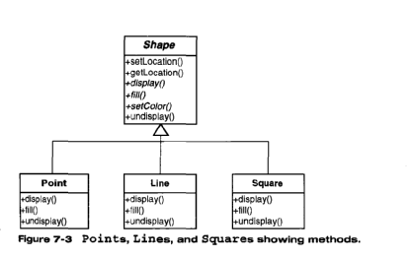
After implementing the above system, the designer was then asked to include a class that could draw triangles. This class should also contain all of the required methods such as display(), fill() and undisplay().
The designer then discovered that a colleague had written a triangle class that perfomed the exact tasks required. Unfortunately the methods within this class were called displayIt(), fillIt(), undisplayIt().
- Using the Adapter pattern, explain in a step-by-step fashion how you would incorporate the given ‘triangle’ class into the above system.

- First would need to create an triangle adapter class
- Within this class need make an instance of the triangle class
- Within each of the method make the instance call the relevant methods in the triangle class, which would be inherited down from the adapter from shape.

- Draw an accurate UML diagram that reflects the updated system.

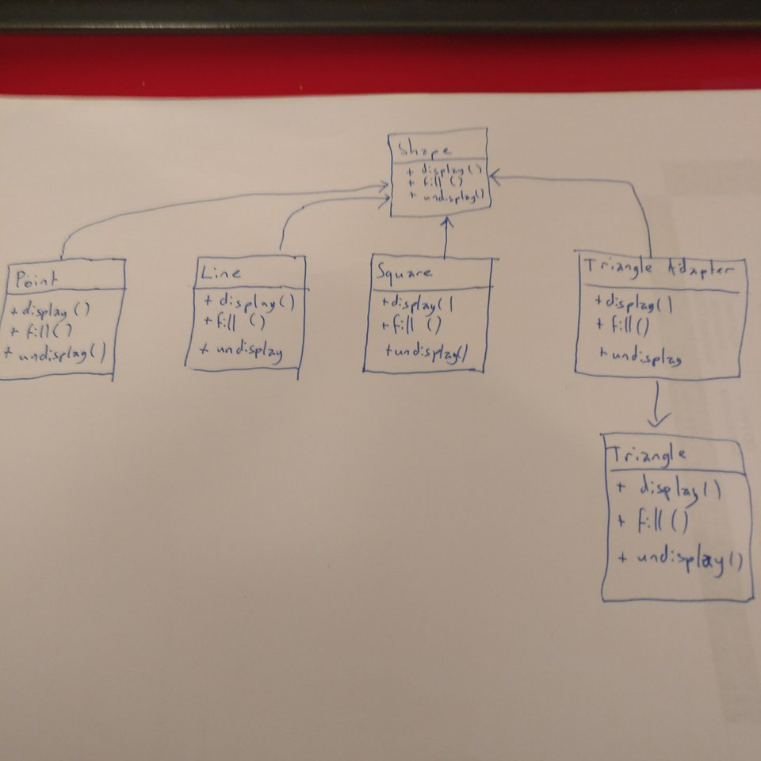

- Provide a Java code fragment for the class ‘triangle’ that implements the Adapter pattern.
